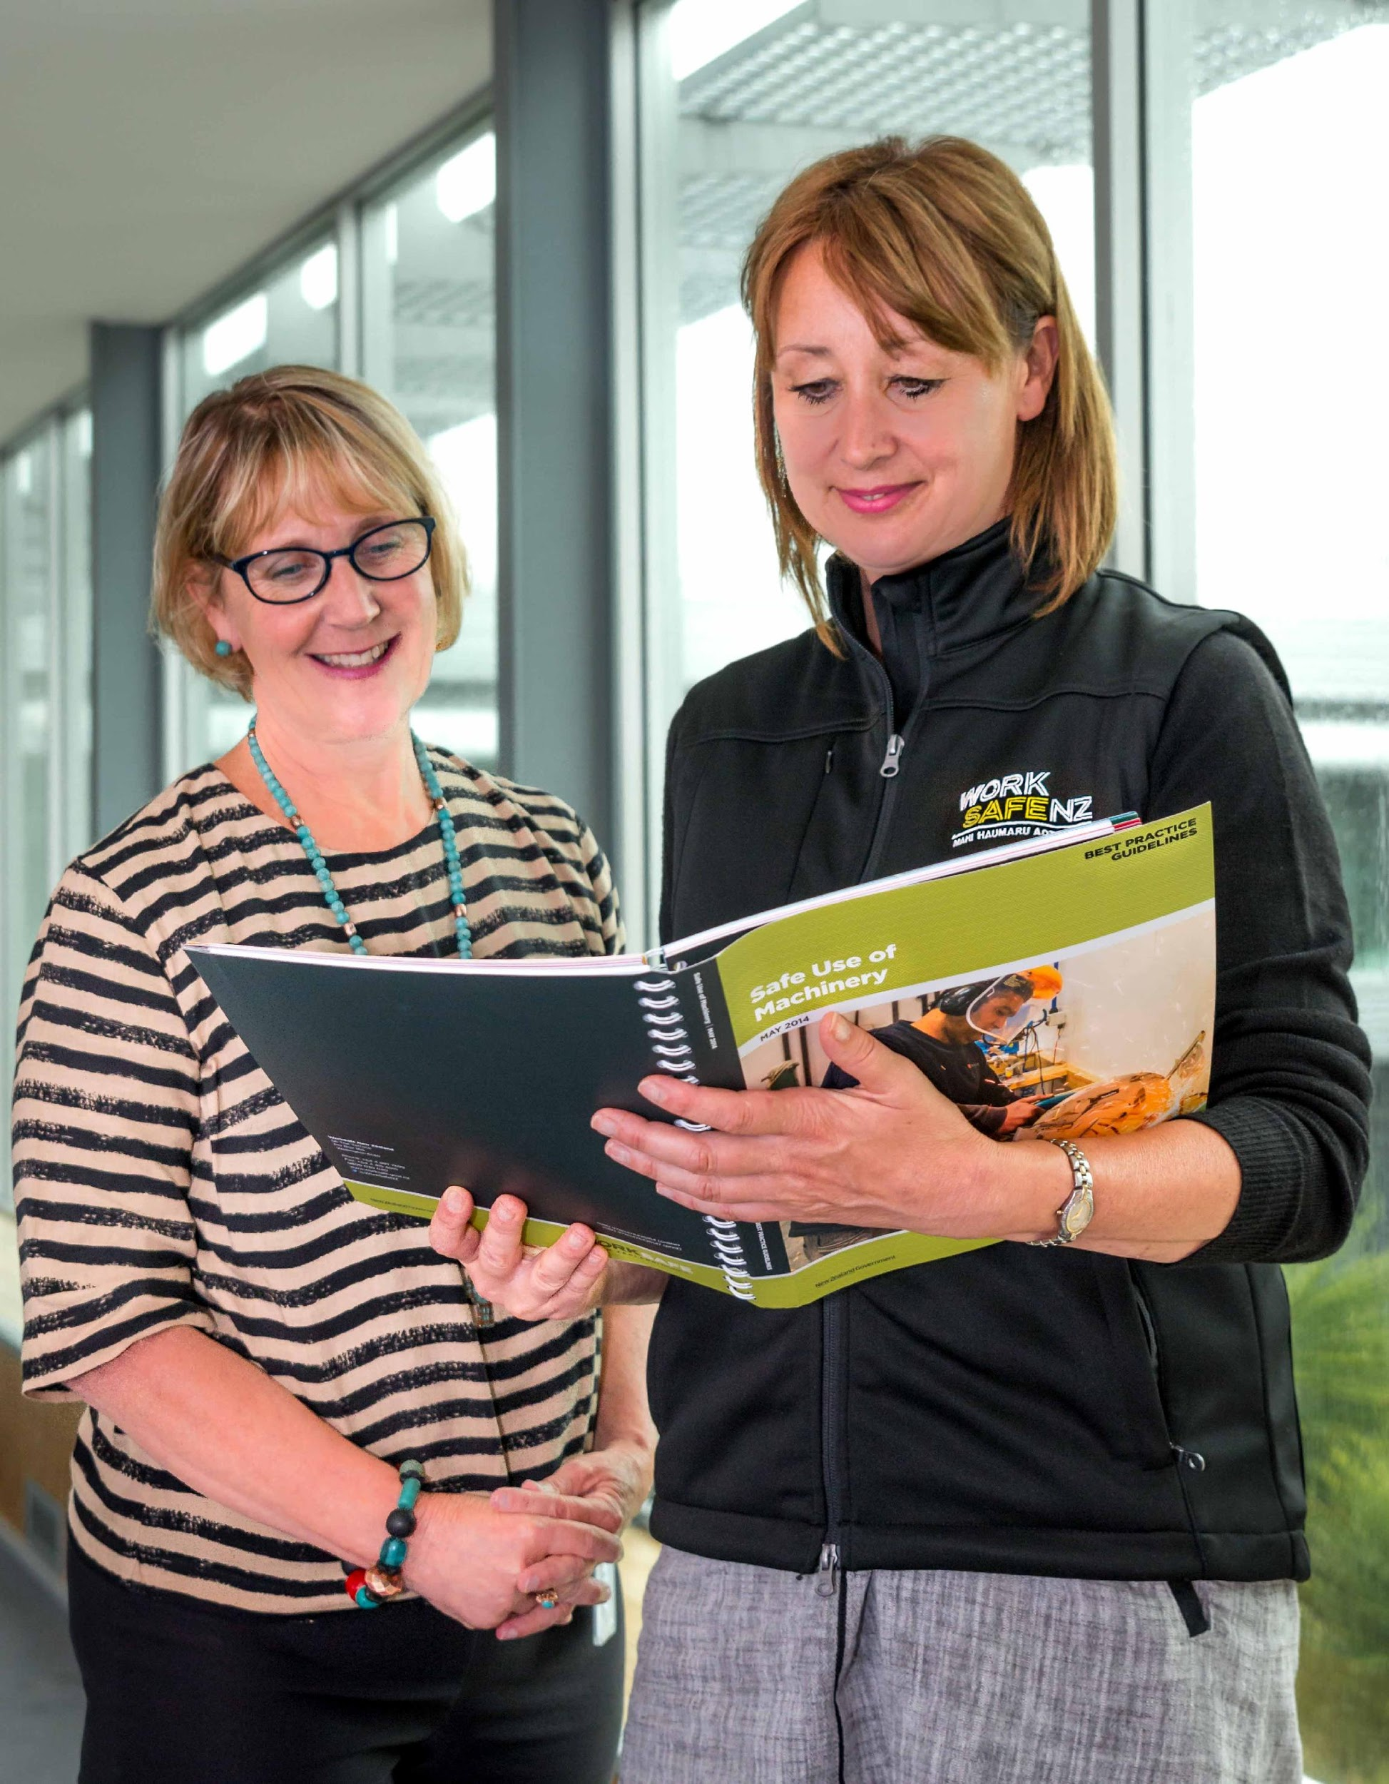  - NZOHNA AGM 2020  & Webinars  THURSDAY 10th SEPTEMBER  This year, we’re adapting to meet COVID-19 challenges. Three (free) webinars will be held in the afternoon, followed by our NZOHNA AGM at 4:30pm. Please do join us, to help celebrate our recent Occupational Health Nursing successes, and earn Continuing Education credits!  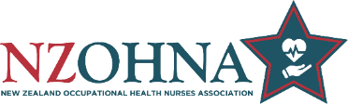 | OVERVIEW  ____  1:30-2:15pm Building the OHN Profession  ____  2:30-3:15pm Workplace Respiratory Update  ____  3:30-4:15pm WorkSafe OH Initiatives  ____  4:30-5:30pm AGM  Registration:  Email admin@nzohna.org.nz Include your webinar selection (e.g. attending all), and if attending AGM.  Please see over for further webinar & AGM details.
The plan is for ½ hour presentation and 15 mins for typed question/chat time.

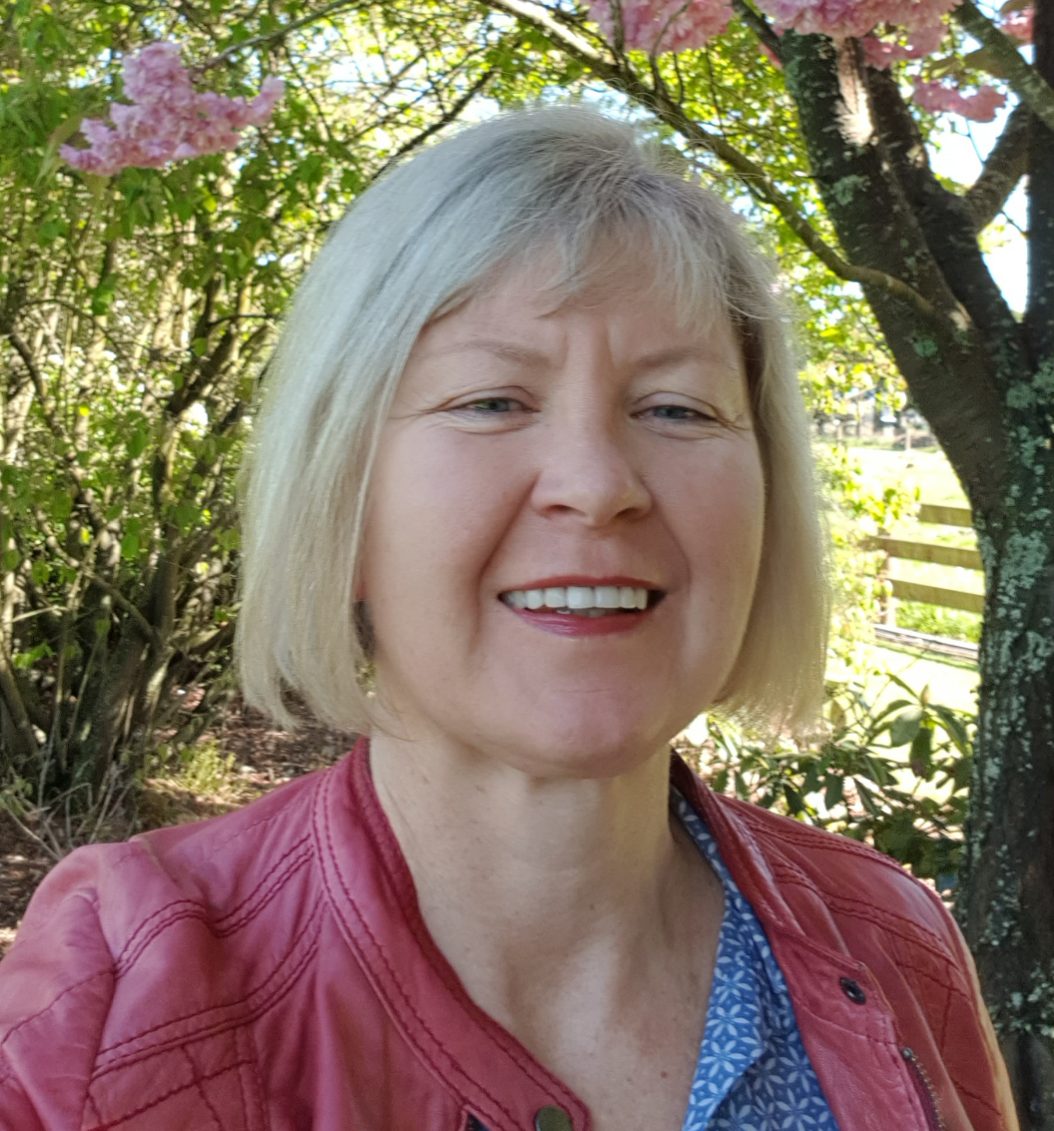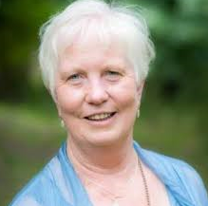 | 1:30-2:15pm Building the OHN Profession (NZOHNA)  Nikki Edge NZOHNA HASANZ Representative & Judy Currie Past HASANZ Representative  NZOHNA, in close collaboration with other parties such as HASANZ members and WorkSafe, has achieved some significant milestones over the last few years. First, we needed to understand our gaps, and then start the journey to build OHN professional capacity and capability. Nikki and Judy’s presentation will focus on providing a:  - HASANZ update; including the H&S Professional Register and  Scholarships; and a  - Professional Workforce Development Project Update

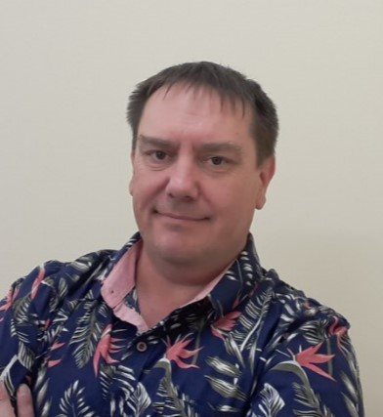 | 2:30-3:15pm Workplace Respiratory Update  David Browning NZOHNA Executive Representative - NZ Dust Disease Task Force.  Emerging health harm risks relating to workplace respirable crystalline silica dust exposure are topical. Various OH&S disciplines are working collaboratively to develop evidence based clinical pathways and resources. During his presentation, David will focus on:  - Spirometry Competency – putting evidence into practice  - Accelerated Silicosis – an update for the Clinical Pathway, Monash Questionnaire and the process for case finding in New Zealand.

3:30-4:15pm Health @ WorkSafe
Api Poutasi (Manager Health) and Debra Perrins (H&S Inspector, OHN)

WorkSafe’s Strategic Plan for Work-Related Health “Healthy Work” outlines the plan for a New Zealand where, ultimately, fewer people experience work-related ill-health. The plan explains the high-level direction and approach to be taken, related activities and the outcomes needed by 2026 to achieve the vision where ‘Everyone who goes to work comes home healthy and safe’.

Api and Debbie will share a summary of current WorkSafe health related initiatives and focus areas for the upcoming year which are underpinned by the strategic plan.

AGM 4:30-5:30pm
- Attendance/Apologies – Quorum met?
- Acceptance of last AGM minutes / Matters Arising?
- President's Annual Report (Heidi Börner / Clare Lynn)
- Annual Financial Report (Kristen Gawn)
- Confirming Executive Positions- President, Treasurer
- General Business/Remit Voting
- Next AGM & NZOHNA Conference

